Project Title: LED Matrix Audio Visualizer

Group Members: Hunter Larson, Andy Liu, Kaitlyn Yau

1. **Project Goal and Functionality**

Our goal is to create an LED cube with the primary function of visualizing audio signals. This will be accomplished by sampling the audio signal from a 3.5mm jack (plugged into a phone or other audio player) a 7-band frequency analyzer and dividing the output into 16 frequency bands.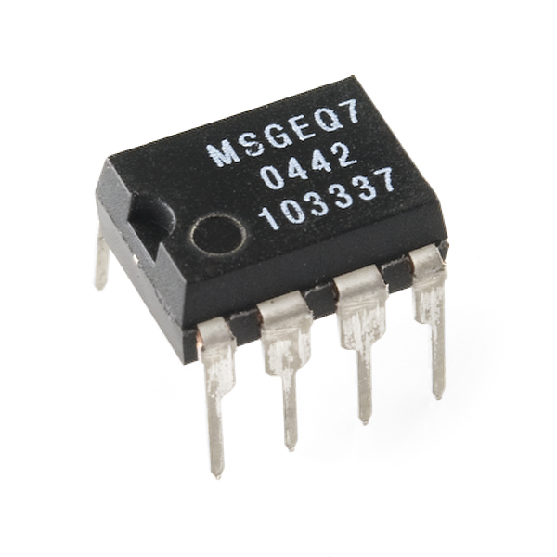

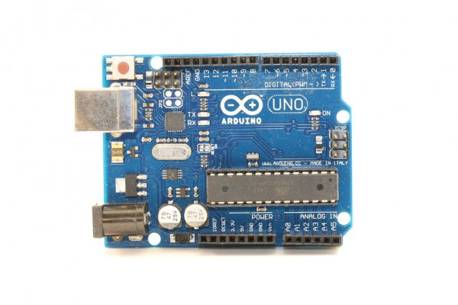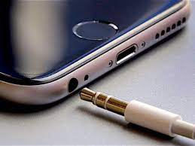

Figure 1: Process for decomposing audio into frequencies components ([Image Credits](https://docs.google.com/document/d/1sJ7cVf4u0EIYqTToMvButSBCdlmTL1YI7-39VEIXNug/edit?usp=sharing))

Once we’ve computed the frequency bands, we will use shift registers to turn on certain columns in the matrix (each column in the cube shares a common anode) while powering only one layer at a time (each layer shares a common cathode). Repeating this process in rapid succession will allow us to create a persistence of vision effect, thus conveying the magnitude of each frequency band by varying the number of LED’s we turn on in each column.

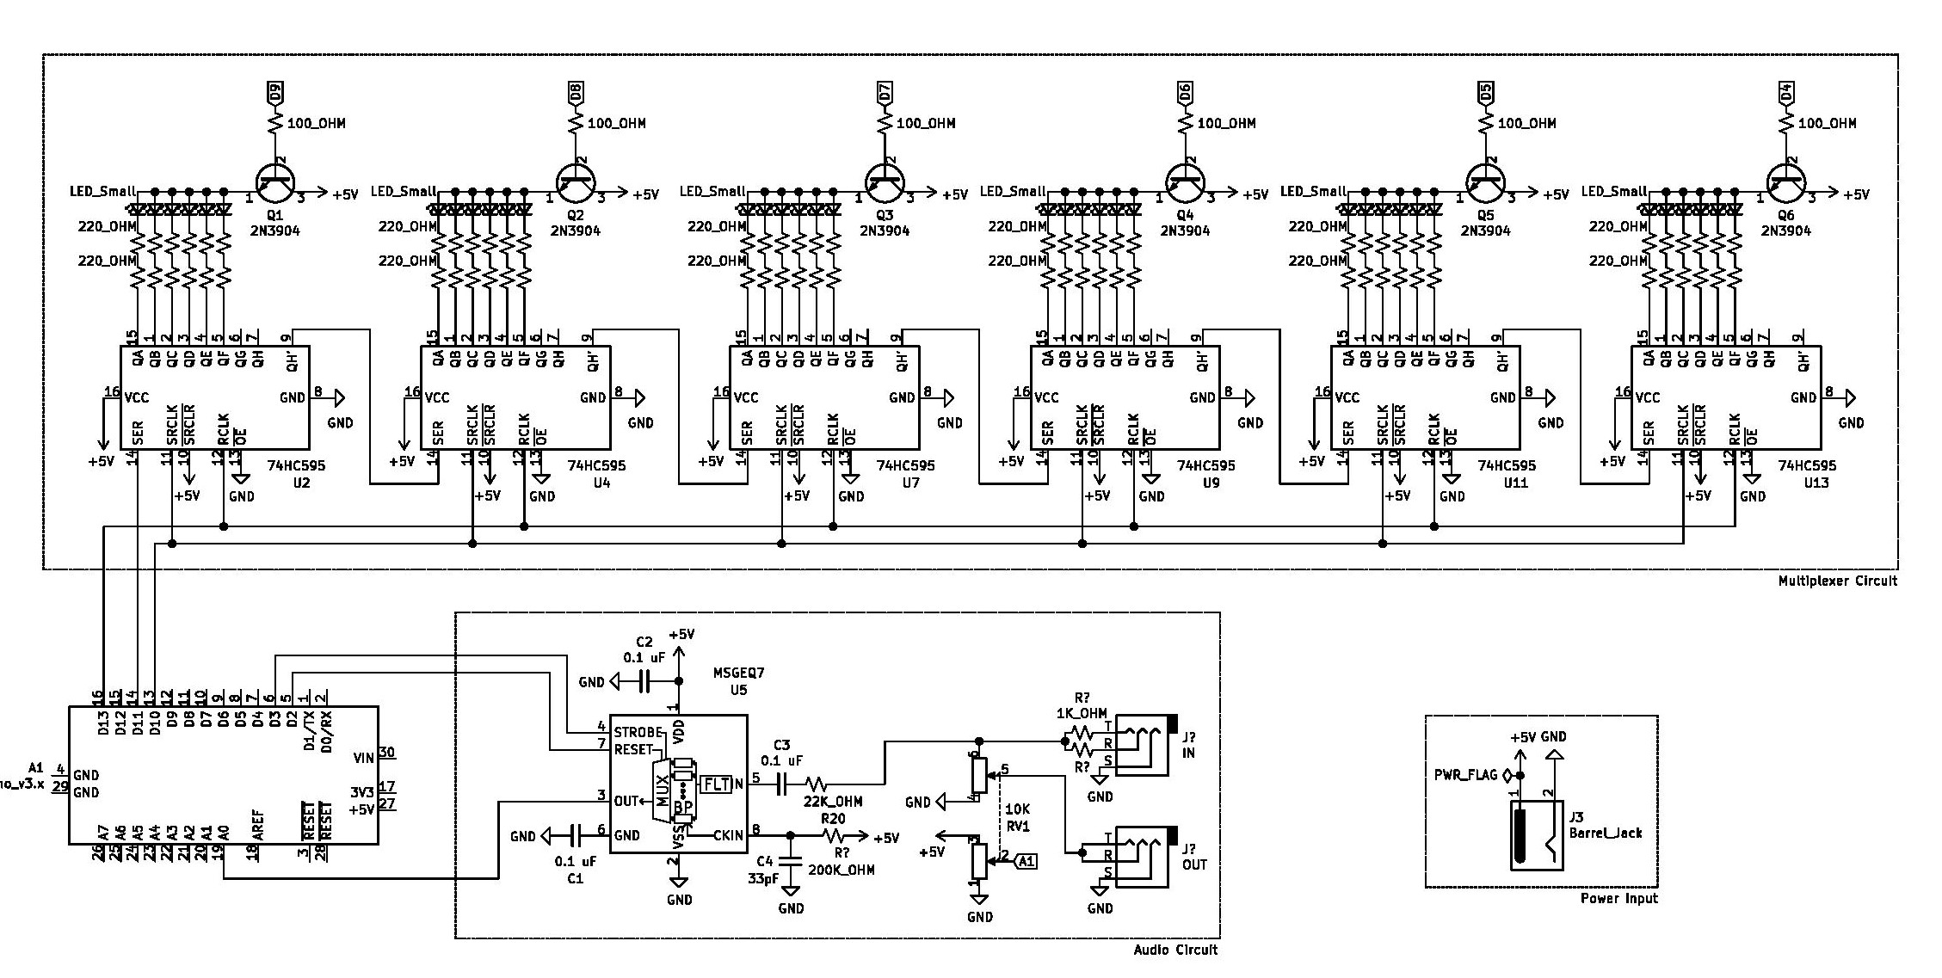

Figure 2: Shows the schematic for both the multiplexer and the MSGEQ7 circuit

Time permitting, we will add the ability to display other patterns on the cube when no audio source is connected.

1. **Hardware Components**
2. 1x Arduino Nano (Already Have)
3. 1x USB Wall Adapter & Cable w/ Barrel Jack (already have)
4. 1x (Female) Barrel Connector for Power (already have)
5. 1x Rocker Switch for Power (already have)
6. 2x 3.5mm Audio Jacks (already have)
7. 6x NPN Transistors (Already Have)
8. 1x [Protoboard](https://www.amazon.com/Double-Sided-Protoboard-Prototyping-10X15CM/dp/B07HFFLGFV/ref=sr_1_6?dchild=1&keywords=large+protoboard&qid=1611857863&sr=8-6)
9. 1x [Seven Band Spectrum Analyzer Board](https://www.amazon.com/MSGEQ7-Spectrum-Analyzer-Breakout-Stereo/dp/B08GY46BY8/ref=sr_1_8?dchild=1&keywords=MSGEQ7&qid=1611957261&s=electronics&sr=1-8&th=1)
10. 216x [Diffused, White LED’s](https://www.amazon.com/100pcs-Ultra-Bright-Emitting-Diffused/dp/B01GE5NB5U/ref=sr_1_17?dchild=1&keywords=white+led+3mm&qid=1611958019&sr=8-17)
11. 72x [220-ohm Resistors](https://www.amazon.com/Projects-100EP512220R-220-Resistors-Pack/dp/B0185FID0K/ref=sr_1_3?dchild=1&keywords=220+ohm+resistor&qid=1611958984&sr=8-3)
12. 6x [Shift Registers](https://www.amazon.com/MCIGICM-74HC595-SN74HC595N-Register-registers/dp/B07HFWB9L9/ref=sr_1_2?dchild=1&keywords=shift+registers&qid=1611856770&sr=8-2)
13. 6x [IC Sockets](https://www.amazon.com/Uxcell-a11090300ux0244-2-54mm-Socket-Adaptors/dp/B0079SM1LW/ref=sr_1_5?dchild=1&keywords=16+pin+ic+socket&qid=1611959612&sr=8-5)
14. 3x [Ribbon Cables](https://www.amazon.com/gp/product/B07FKRYJVR/ref=ppx_yo_dt_b_asin_title_o02_s00?ie=UTF8&psc=1)
15. 3x [Connectors For Ribbon Cables](https://www.amazon.com/JZK-crimper-crimping-connectors-assorted/dp/B07PCQ5VMV/ref=sr_1_4?dchild=1&keywords=ribbohttps://www.amazon.com/gp/product/B0834RW6X8/ref=ppx_yo_dt_b_asin_title_o02_s00?ie=UTF8&psc=1)

Price Breakdown:

1. Arduino - $0
2. Power Supply - $0
3. Barrel Connector - $0
4. Rocker Switch - $0
5. 3.5mm Jacks - $0
6. Transistors - $0
7. Protoboard - $12
8. Spectrum Analyzer - $20
9. LED’s - $19
10. Resistors - $7
11. Shift Registers - $7.50
12. IC Sockets - $7
13. Ribbon Cables - $9
14. Ribbon Cable Connectors - $7

Total: $81.5

1. **Design Timeline**
2. Week 5: Order parts
3. Week 6: Start building LED Matrix, Start Controller Circuit
4. Week 7: Finish Controller Circuit, Start Programing
5. Week 8: Finish Programming, finish building LED matrix
6. Week 9: Debugging and/or Additional Patterns
7. **Documentation**
8. [Github Repo](https://github.com/hslarson/ECE-5-LED-Cube)
9. [MSGEQ7 Datasheet](https://www.digikey.com/htmldatasheets/production/1844111/0/0/1/msgeq7.html)
10. [LED Datasheet](https://www.vishay.com/docs/85198/vlhw4100.pdf)
11. [Shift Register Datasheet](https://www.ti.com/lit/ds/scls041i/scls041i.pdf?ts=1611948098373)
12. [Transistor Datasheet](https://www.sparkfun.com/datasheets/Components/2N3904.pdf)